**Exercise 4: Creating and Configuring a Maven Project**

**Step-1:** Created a maven project with name **LibraryManagement.**

**Step-2:** Added Spring Dependencies in pom.xml**e**

(Include dependencies for Spring Context, Spring AOP, and Spring WebMVC.)

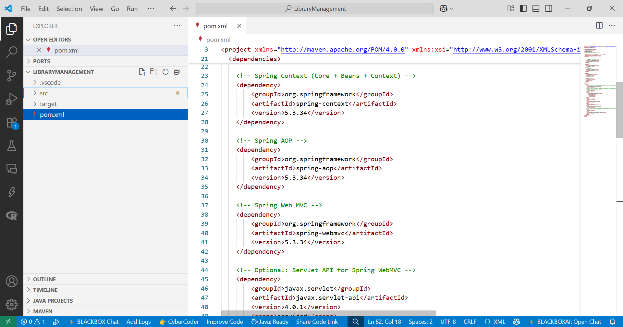

**Step-3:Configured Maven Plugins:**

* + Configured the Maven Compiler Plugin for Java version 1.8 in the pom.xml file.

 <plugin>

            <groupId>org.apache.maven.plugins</groupId>

            <artifactId>maven-compiler-plugin</artifactId>

            <version>3.11.0</version>

            <configuration>

                <source>1.8</source>

                <target>1.8</target>

            </configuration>

 </plugin>

